- Screenshots of the program output.
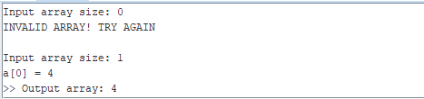
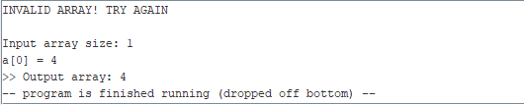

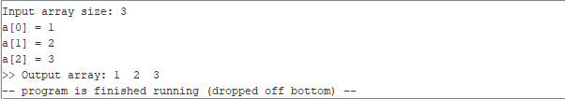

- What percentage of the work is done?
- 96,69%, I guess

